1. A)

|  |  |  |  |  |  |  |  |
| --- | --- | --- | --- | --- | --- | --- | --- |
| **Activity** | **Dependency** | **Duration (Days)** | **(End of Day) ES** | **(End of Day) EF** | **(End of Day) LS** | **(End of Day) LF** | **Float (Days)** |
| **A** | NONE | 10 | 0 | 10 | 0 | 10 | 0 |
| **B** | A | 5 | 10 | 15 | 18 | 23 | 8 |
| **C** | B | 15 | 15 | 30 | 23 | 38 | 8 |
| **D** | A | 3 | 10 | 13 | 29 | 32 | 19 |
| **E** | A | 8 | 10 | 18 | 10 | 18 | 0 |
| **F** | E | 20 | 18 | 38 | 18 | 38 | 0 |
| **G** | D | 6 | 13 | 19 | 32 | 38 | 19 |
| **H** | C, F, G | 10 | 38 | 48 | 38 | 48 | 0 |

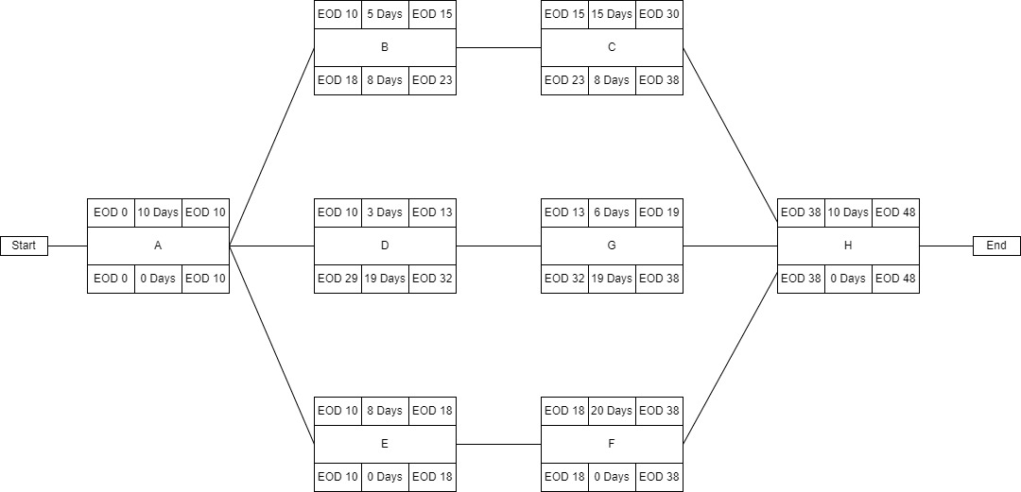 B) Activity Network:

C) Critical Path: A -> E -> F -> H Duration: 48 Days.

Question 2:

1. Activity A: $t_{e}=\frac{a+4m+b}{6}=\frac{6+4\left(7\right)+9}{6}=7.17$

Activity B: $t_{e}=\frac{a+4m+b}{6}=\frac{4+4\left(5\right)+7}{6}=5.17$

Activity C: $t_{e}=\frac{a+4m+b}{6}=\frac{7+4\left(9\right)+15}{6}=9.67$

Activity D: $t_{e}=\frac{a+4m+b}{6}=\frac{6+4\left(7\right)+7}{6}=6.83$

Activity E: $t_{e}=\frac{a+4m+b}{6}=\frac{4+4\left(7\right)+8}{6}=6.67$

Activity F: $t_{e}=\frac{a+4m+b}{6}=\frac{12+4\left(16\right)+17}{6}=15.50$

Activity G: $t_{e}=\frac{a+4m+b}{6}=\frac{8+4\left(12\right)+20}{6}=12.67$

Activity H: $t_{e}=\frac{a+4m+b}{6}=\frac{8+4\left(9\right)+18}{6}=10.33$

Activity I: $t_{e}=\frac{a+4m+b}{6}=\frac{10+4\left(16\right)+18}{6}=15.33$

Activity J: $t_{e}=\frac{a+4m+b}{6}=\frac{8+4\left(14\right)+20}{6}=14.00$

Activity K: $t_{e}=\frac{a+4m+b}{6}=\frac{9+4\left(9\right)+14}{6}=9.83$

1. 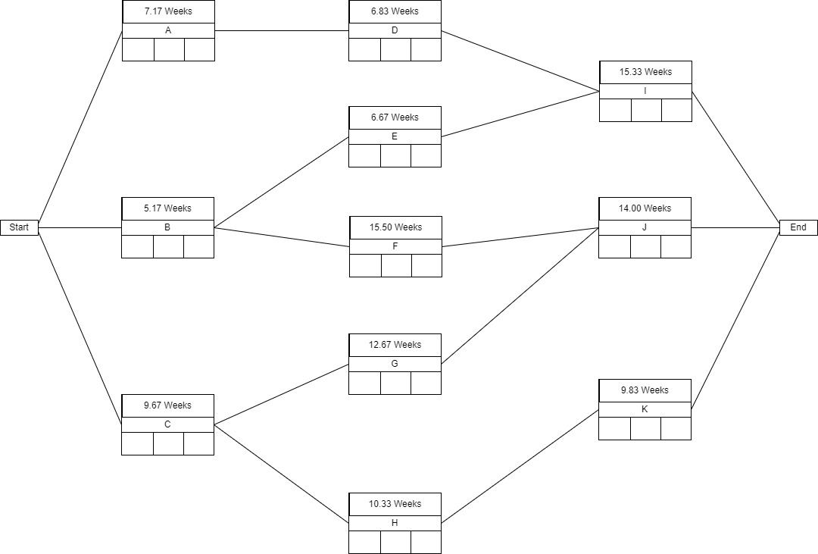
2. The critical path is C -> G -> J because it has the longest duration of any path. The expected duration of the project is 36.34 weeks, which is the duration of the critical path.
3. Activity A: $S_{1}=\frac{b-a}{3.3}=\frac{9-6}{3.3}=0.91$

Activity B: $S_{1}=\frac{b-a}{3.3}=\frac{7-4}{3.3}=0.91$

Activity C: $S_{1}=\frac{b-a}{3.3}=\frac{15-7}{3.3}=2.42$

Activity D: $S_{1}=\frac{b-a}{3.3}=\frac{7-6}{3.3}=0.30$

Activity E: $S_{1}=\frac{b-a}{3.3}=\frac{8-4}{3.3}=1.21$

Activity F: $S_{1}=\frac{b-a}{3.3}=\frac{17-12}{3.3}=1.52$

Activity G: $S_{1}=\frac{b-a}{3.3}=\frac{20-8}{3.3}=3.64$

Activity H: $S_{1}=\frac{b-a}{3.3}=\frac{18-8}{3.3}=3.03$

Activity I: $S_{1}=\frac{b-a}{3.3}=\frac{18-10}{3.3}=2.42$

Activity J: $S_{1}=\frac{b-a}{3.3}=\frac{20-8}{3.3}=3.64$

Activity K: $S_{1}=\frac{b-a}{3.3}=\frac{14-9}{3.3}=1.52$

1. Activity A: $S_{1}=\frac{b-a}{6}=\frac{9-6}{6}=0.50$

Activity B: $S_{1}=\frac{b-a}{6}=\frac{7-4}{6}=0.50$

Activity C: $S_{1}=\frac{b-a}{6}=\frac{15-7}{6}=1.33$

Activity D: $S_{1}=\frac{b-a}{6}=\frac{7-6}{6}=0.17$

Activity E: $S_{1}=\frac{b-a}{6}=\frac{8-4}{6}=0.67$

Activity F: $S_{1}=\frac{b-a}{6}=\frac{17-12}{6}=0.83$

Activity G: $S_{1}=\frac{b-a}{6}=\frac{20-8}{6}=2.00$

Activity H: $S_{1}=\frac{b-a}{6}=\frac{18-8}{6}=1.67$

Activity I: $S_{1}=\frac{b-a}{6}=\frac{18-10}{6}=1.33$

Activity J: $S_{1}=\frac{b-a}{6}=\frac{20-8}{6}=2.00$

Activity K: